

Deductible Alert Indicator

Requirement Document

**Version 1.1**

|  |  |
| --- | --- |
| ***Corporate Office & Development Center*** | ***Offshore Development Center*** |
| *1 Pickering Street*  *#06-03 Great Eastern Centre*  *Singapore 048659* | *Plot # 122 & 123, N.S.E.Z, Phase -2*  *NOIDA, UP 201 305*  *India*  *Tel: 91.11.91.2510483* |

|  |  |  |  |  |
| --- | --- | --- | --- | --- |
| **Author** | | | | |
| **Name** | **Role** | **Date of Preparation** | **Signature** | |
| Evelyn Yap | Project manager | 26-Jan-2015 | Evelyn | |
| **Reviewer(s)** | | | | |
| **Name** | **Role** | **Date of Review** | **Signature** | |
| Pravesh Kumar | Manager Projects |  |  | |
|  |  |  |  | |
| **Approver** | | | | |
| **Name** | **Role** | **Date of Approval** | **Signature** | |
| ChengChoon Yip | VP Ebix Exchange  Asia |  |  | |
| **Document Path** | **Version Number** | **Date of Release** | | |
|  | 1.00 | 26-Jan-2015 | | |
| **Revision History** | | | | |
| **Version Number** | **Date of Release** | **Section/ Page # Changed** | | **Details of Changes** |
| 1.00 | 26-Jan-2015 | All | | Document created |
| 1.1 | 24-Feb-2015 | All | | Added Requirements Section and Updated Flowchart |

|  |  |  |
| --- | --- | --- |
| **References** | | |
| **Document** | **Date Received** | **Author** |
|  |  |  |

Contents

1. Overview 4

**a.** Module 4

**b.** Development Type 4

2. Requirements 5

i. The Alert Indicator is only used for BI Claim Types only. It is not applicable for OD and PD Claim Types. 5

ii. The Deductible Amount is based on the Organization Category and Organization Name in the Deductible Master. 5

iii. The Deductible Amount is applied per accident basis. 5

iv. The Alert Indicator will be triggered when a Mandate or Payment Request is created by CO. The Alert Indicator will also be triggered when the Supervisor approves the Mandate or Payment Request (if the CO submitted the request instead of canceling the request after receiving the Alert Indicator during the request stage) 5

v. Total Amount To Date = Total Payment Made to Date + Any Previous Approved Mandate/Payment Request 5

3. Case 1 6

4. Case 2 7

5. Rule 8

6. Implementation 8

Current Implementation 8

Targeted Implementation 8

7. Change Required 8

# Overview

The Alert Indicator is only for TPBI Claims. Different organizations will have differing deductible amounts. The deductible amount will be set up in the System Admin during the setup of the Organization Master Table. The Alert Indicator will be triggered as per the description in the flow chart below.

|  |  |  |  |
| --- | --- | --- | --- |
| ☒ | New | ☐ | Change Request |

* 1. Module

|  |  |  |  |  |  |
| --- | --- | --- | --- | --- | --- |
| ☐ | Diary | ☐ | System Admin Module | ☒ | Claim Registration |
| ☒ | Claim Payment | ☐ | Claim Recovery | ☐ | Claim Enquiry |
| ☐ | Upload | ☐ | Reports |  |  |

* 1. Development Type

|  |  |  |  |  |  |
| --- | --- | --- | --- | --- | --- |
| ☒ | Functionality | ☒ | Integration | ☐ | Rule |
| ☐ | Report | ☒ | Field | ☒ | Screen |

# Requirements

* The Alert Indicator is only used for BI Claim Types only. It is not applicable for OD and PD Claim Types.
* The Deductible Amount is based on the Organization Category and Organization Name in the Deductible Master.
* The Deductible Amount is applied per accident basis.
* The Alert Indicator will be triggered when a Mandate or Payment Request is created by CO. The Alert Indicator will also be triggered when the Supervisor approves the Mandate or Payment Request (if the CO submitted the request instead of canceling the request after receiving the Alert Indicator during the request stage)
* Total Amount To Date = Total Payment Made to Date + Any Previous Approved Mandate/Payment Request

# Case 1

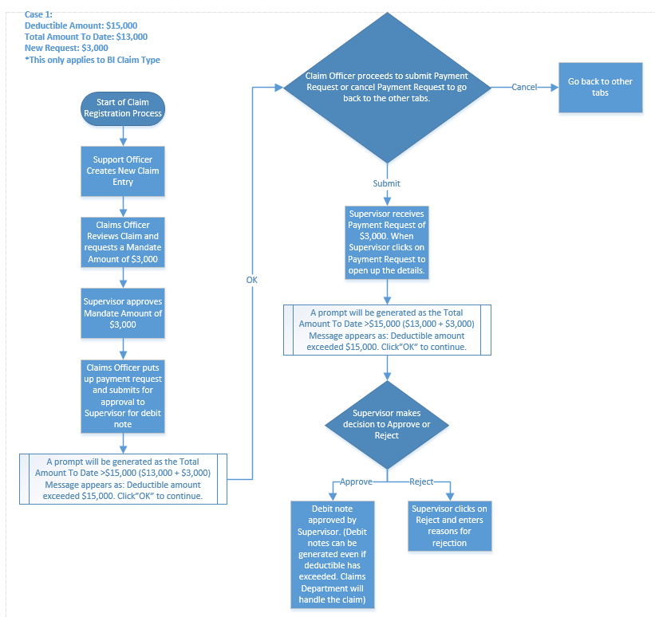

# Case 2

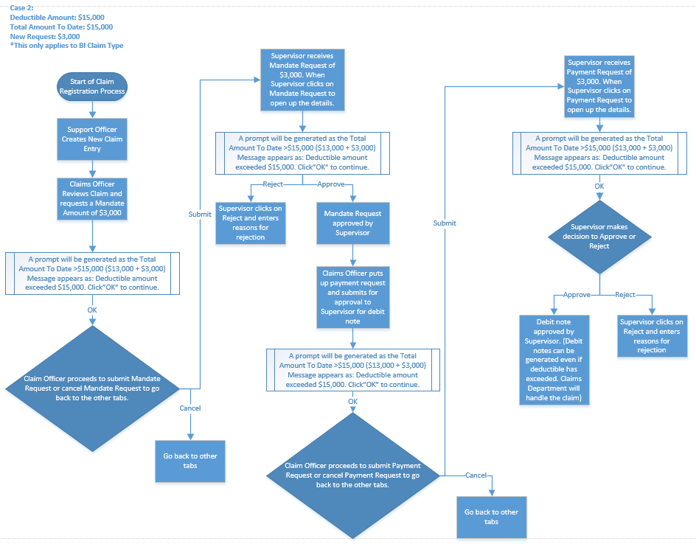

# Rule

|  |  |  |  |  |
| --- | --- | --- | --- | --- |
| **IF** | **Then** | **Else** | **And** | **Or** |
|  |  |  |  |  |
|  |  |  |  |  |

# Implementation

## Current Implementation

* Deductible Alert Indicator does not exist in application

## Targeted Implementation

* Deductible Alert Indicator Creation

# Change Required